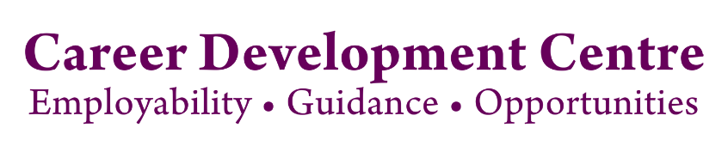

Remote Working Placements – Tips for Employers

The outbreak of the coronavirus (Covid-19) has seen many companies explore the possibility of remote working placements. Here are some practical tips for employers who are interested in offering a student placement that is to be either partially or fully carried out remotely. The information provided is based on feedback from NUI Galway Placement employers partners where students started in work placement in summer 2020 on a remote working basis.

Equipment

Employers provided equipment such as laptops, desktops, monitors, wireless keyboard/mouse and software to students for remote working on placement. One employer provides a ‘Work from Home’ pack to each student which includes a monitor, a small form factor PC, a keyboard, a mouse, a power strip and an Ethernet cable.

Others employers provide additional equipment such as headsets or office chairs if requested by students.

Some employers simply require the student to have a WIFI connection and their own laptop.

Companies also direct students to the HSA’s ‘Position Yourself Well’ infographic which outlines good practice in the areas of workspace organisation and ergonomics.
https://www.besmart.ie/fs/doc/handout_cutout_for_web.pdf

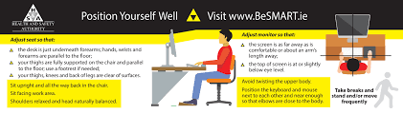
Induction

Employers have reported a positive outcome to their remote on-boarding processes. Employers use web-based training materials and zoom/teams calls with students for 1-1 or group meetings.

In most cases the students’ line managers, company HR staff and other relevant stakeholders deliver virtual presentations in the early days and weeks of the placement.

‘Buddy’ system

A ‘buddy’ system is used by many employers for onsite and remote placements. The importance of such a system is amplified in a remote work setting. Employers highlight the success of using a buddy system in helping students to settle into both the company and their roles.

In most cases the student’s manager assigns a teammate to constantly keep in touch with the student. This generally involves daily check-in meetings to catch up and set priorities. One employer noted that assigning students to small virtual working groups for specific projects had worked well.

Flexible work schedules

A number of employers have extended their flexible work schedules to students on placement. Many employers noted the increased importance of work-life balance among their staff currently and this also applies to students on placement.

Supervision

Employers surveyed outlined various ways of supervising students on remote working placements. Some organise weekly virtual 30 minute meetings with the student to discuss his/her performance and to share feedback.

Others meet virtually for 15 minutes at 10am each morning to review their work with the team and hold a follow up virtual meeting at 2pm each day to review specific topics.

Some employers hold a daily video ‘stand-up’ call every morning where they discuss what was done the previous day, what is to be done today and any blockers.

A common theme among employers is that they try not to micromanage students while on remote working placement where possible. Instead they encourage the autonomy of the student in the role. Students in one multinational company are encouraged to improve prioritisation skills e.g. compiling priority lists for the day.

Further information

Enterprise Ireland infographic on remote working:
https://eilearn.ie/practical-steps-for-managing-remote-working/

Health and Safety Authority’s FAQs for Employers in relation to home-working on a temporary basis:
https://www.hsa.ie/eng/topics/covid-19/covid-19_faqs_for_employers_and_employees_in_relation_to_home-working_on_a_temporary_basis

